NEWS FROM SunInfo
The SunInfo website provides regular updates of Information and News to those with an interest in sundials.
Its home page is to be found at:
http://www.bit.ly/suninfo
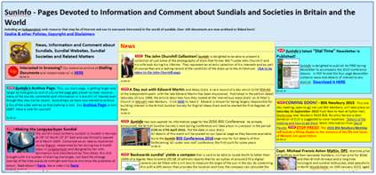
Recent additions to the site which you might like to explore are:
• Our newly opened page about the forthcoming 2016 BSS Liverpool Conference
• Information about the next 2015 BSS Newbury Meeting in September
• The new gallery of images taken around the millennium by the late John Churchill
• The latest SunInfo DialTime Newsletter
• BSS President Christopher Daniel's web site
• Christopher Daniel’s success regarding the security of his library books
• The astonishing list of all Christopher Daniel's publications
• David Payne’s Norfolk sundial trail
• The SunInfo 2015 Calendar
• Our New Archive of earlier SunInfo entries
• Our obituary to Michael Maltin DFC, Wartime Pilot, Horologist, Diallist and Gentleman
• Our updated reference collection of documents relating to sundials and sundial societies
And, of course, a whole lot more....
We hope you will enjoy visiting SunInfo

We try hard to ensure that the information and views expressed on SunInfo are both complete and correct and that no copyright has been infringed. If you have noticed an error or an omission or can suggest an improvement, a useful addition, or if you believe that any specific copyright may have been infringed, wrongly attributed or has been the subject of any actual or implied transfer of rights away from the original author, then please do send an email giving full details to the webmaster and action will always be taken, apologies issued and appropriate and corrective text inserted.
This email was sent to you because we believe you have expressed an interest in sundials. If this is not, or is no longer, the case please let us know that you wish to unsubscribe

